
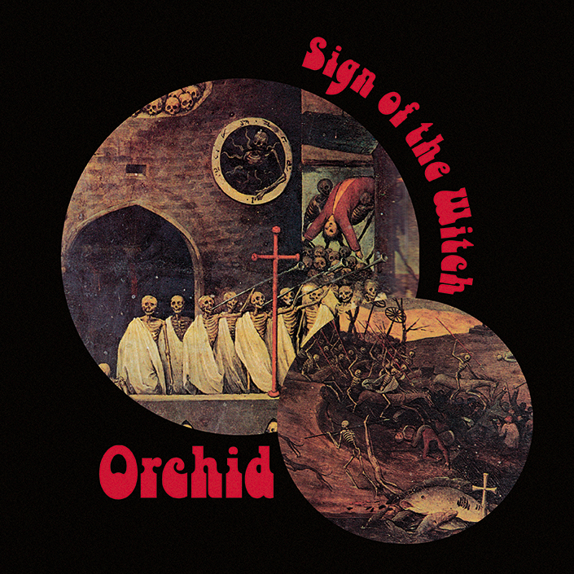

ORCHID
»Sign Of The Witch«

OUT: May 22, 2015

Line up: | Orchid online:
Theo Mindell | vocals  Carter Kennedy | drums  Mark Thomas Baker | guitar  Keith Nickel | bass | www.orchidsf.com  www.facebook.com/orchidsf  www.twitter.com/orchid_sf  www.youtube.com/user/orchidsf  www.nuclearblast.de/orchid
Founded in 2006 with the sole intention of a bunch of buddies playing some rock music, things went pretty fast for San Francisco’s finest, ORCHID. No three years later, the band would release their first EP, »Through The Devil’s Doorway«, which set the foundation for a bright future – causing a real buzz in the underground, 2011’s debut album, »Capricorn«, took ORCHID’s promising, but still young career to a whole new level. Receiving raving reviews all around the world, the band embarked on a first, successful European tour to bring their perfect blend of 70ies psychedelic heavy rock to the stages.
Pretty much right after that, Nuclear Blast offered the band a deal. Again, things turned for the best for ORCHID – before releasing their second full-length album, the two collector’s EPs, »Heretic« and »Wizard Of War«, sold out in no time and prepared the steadily growing fan base for what was to come. With the release of »The Mouths Of Madness« (hitting the official German media control charts at #18), the following highly successful tour with label mates FREE FALL and the frenetically celebrated show at renowned Rock Hard Festival pushed ORCHID to the very top of today’s vintage rock scene.
The second tour in 2013, supported by label mates BLUES PILLS and SCORPION CHILD had the band explore more new grounds and cemtented their status as highly authentic and atmospheric live band.

After a few months off, ORCHID went back to writing mode and came up with what will be soon available as another milestone EP: »Sign Of The Witch« shows the band's signature sound while exploring the beauty of variety by including more psych, more groove, more infectious hooks and even more blues. This harbinger for the band's highly anticipated new album will let you guess what they're up to in the near future.

On a side note: being one of METALLICA guitarist Kirk Hammett’s most favourite bands, the legendary axeman invited ORCHID to play at his very own horror convention “Kirk von Hammett’s Fear FestEvil” the second year in a row.

Don't miss out on ORCHID this summer when they return to the old country:
29.05.2015 DE München - Rockavaria
30.05.2015 DE Nürburgring - Grüne Hölle
02.06.2015 DE Berlin - Bi Nuu
03.06.2015 DE Dresden -Scheune
04.06.2015 DE Geiselwind - Out & Loud
05.06.2015 DE Netphen-Deutz - Freak Valley Festival
10.06.2015 DE Lindau - Club Vaudeville
11.06.2015 IT Milan - Magnolia (/w Blues Pills)
14.06.2015 AT Nickelsdorf - Novarock
16.06.2015 CH Pratteln - Z7 Mini
19.06.2015 FR Clisson - Hellfest
20.06.2015 BE Dessel - Graspop
21.06.2015 GR Athen - Kytarro Live Club
23.06.2015 ES Barcelona - Boveda

ORCHID discography:
2009 »Through The Devil's Doorway«
2011 »Capricorn«
2012 »Heretic«
2013 »Wizard Of War«
2013 »The Mouths Of Madness«
2013 »The Zodiac Sessions«
2015 »Sign Of The Witch«
© Nuclear Blast

